CHC22015M Certificate II in Community Services
Release: 4

CHC22015M Certificate II in Community Services
DRAFT

Modification History
Release | Comments
Release 1 | This version released with CHC Community Services Training Package Version 11.  CHC22015M Certificate II in Community Services supersedes and is not equivalent to CHC22015 Certificate II in Community Services.  Major changes to core and elective units of competency.

Qualification code  DRAFT  Mandatory field | CHC22015M
Qualification title  Mandatory field | Certificate II in Community Services
Qualification description  Mandatory field | This qualification provides a foundation for further study and entry into sectors related to the community services. It prepares individuals for entry-level support roles. Work includes routine tasks that support service delivery and administration, carried out under direct supervision and within clearly defined guidelines.  The skills in this qualification must be applied in accordance with Commonwealth and State or Territory legislation, Australian standards and industry codes of practice.
Foundation skills outcomes  Mandatory field | The foundation skills outcomes implicit in this qualification are outlined in the below bar chart.  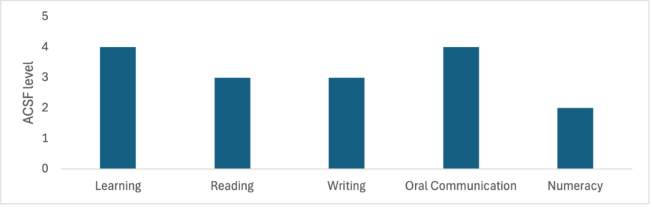  Note: Some elective units require higher foundation skills levels. Please refer to the Companion Volume Implementation Guide for more information.
Entry requirements  Optional field | N/A
Qualification mapping information  DRAFT  Mandatory field | CHC22015M Certificate II in Community Services supersedes and is not equivalent to CHC22015 Certificate II in Community Services
Packaging Rules | Total number of units = 9  - 6 core units  - 3 elective units, consisting of:  - at least 1 unit from the electives listed below  - up to 2 units from the electives listed below, any endorsed Training Packages or accredited courses – these units must be relevant to the work outcome  All electives chosen must contribute to a valid, industry-supported vocational outcome.  * Indicates proposed draft title – subject to further consultation  M indicates proposed major changes  X indicates cross sector
  Core units
  BSBPEF202 | Plan and apply time management
  CHCCOM001M | Provide first point of contact
  CHCCOM005M | Communicate and work in health or community services
  CHCDIV001M | Work with diverse people
  HLTWHS001 | Participate in workplace health and safety
  HLTWHS006 | Manage personal stressors in the work environment
  Elective units
  BSBTEC201 | Use business software applications
  BSBTEC202 | Use digital technologies to communicate in a work environment
  BSBWHS332 | Apply infection prevention and control procedures to own work activities
  BSBWRT311 | Write simple documents
  CHCAGE013 | Work effectively in aged care
  CHCCDE019 | Work within a community development framework
  CHCDEV004M | Confirm developmental status
  CHCDFV001M | *Identify and respond to family, domestic and/or sexual violence
  CHCDIV002M | * Support culturally responsive practices with Aboriginal and/or Torres Strait Islander peoples
  CHCECE031 | Support children's health, safety and wellbeing
  CHCECE040  DRAFT | Attend to daily functions in home-based child care
  CHCLEG001 | Work legally and ethically
  CHCPRT025 | Identify and report children and young people at risk
  CHCVOL001 | Be an effective volunteer
  FSKDIG003 | Use digital technology for non-routine workplace tasks
  FSKLRG009 | Use strategies to respond to routine workplace problems
  FSKLRG011 | Use routine strategies for work-related learning
  FSKNUM014 | Calculate with whole numbers and familiar fractions, decimals and percentages for work
  FSKOCM007 | Interact effectively with others at work
  FSKRDG010 | Read and respond to routine workplace information
  FSKWTG009 | Write routine workplace texts
  HLTAAP001 | Recognise healthy body systems
  HLTAID011 | Provide first aid
  PSPLAN003 | Source information on Deaf culture, and communicate according to Deaf protocol
  SITXFSA006 | Participate in safe food handling practices


